time range Organisation, City, Country

* Your tasks and
* responsibilities

 Volunteering

time range Company, City, Country

* Your tasks and
* responsibilities

time range Company, City, Country

* Your tasks and
* responsibilities

 Work Experience

time range Master Study

University, City, Country

* Focus
* Case study project
* Topic of the Master thesis:
* Degree: 1,9

time range Semester abroad at Lund University, Sweden

* Focus on marketing and corporate communication

time range Bachelor Study E

University, City, Country

* Bachelor thesis topic:
* Degree: 1,9

time range School, City, Country

A-levels, Degree 2,3

 Education

**Objective**

Your goals

**Career Summary**

* Important skills for the job
* Soft Skills and
* Professional skills

**Skills and Interests**

*Language*

*Computer Skills*

*Sports*

*Interests*

**Personal Data**

address

Telephone

email

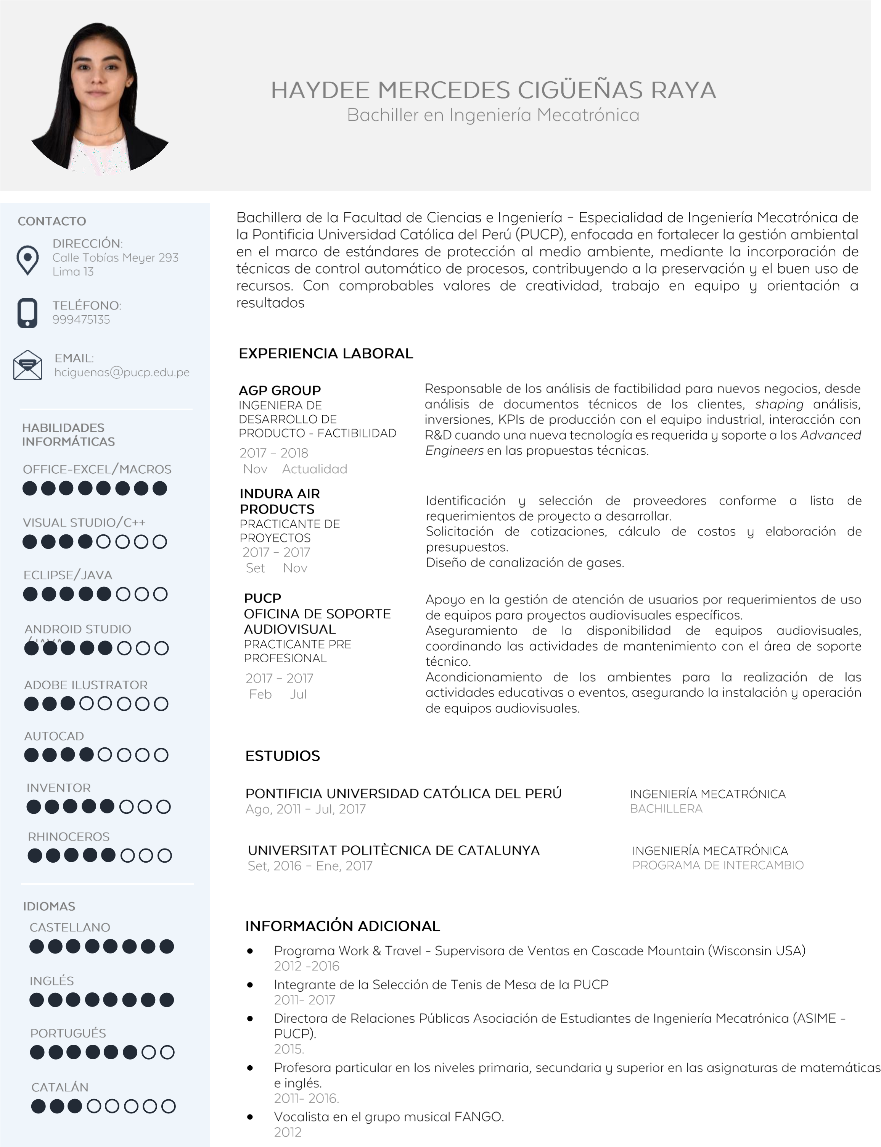

CURRICULUM VITAE

**Your first and last name**